Georges Cabanis High School
Brive-la-Gaillarde
New-Aquitaine Region
France

2017 Destination Entreprise
Challenge Project

Self-entrepreneur Challenge
Creation of an Industrial equipment
maintenance service using
a self-entrepreneur's status
and an internet platform

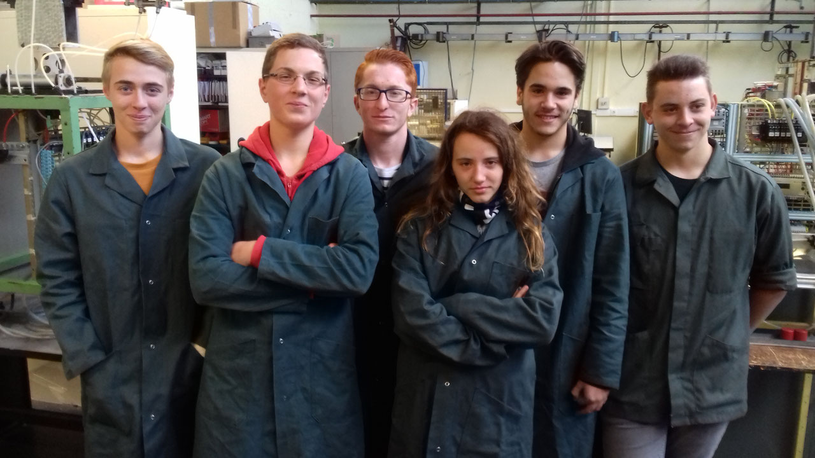

From left to right :
Melvin SIMONOT, Émilien BROUXEL, Maurin SAUSSET,
Tatania SILVESTRINI, Mickaël LEITAO, Daniel SHARPS

Industrial Equipment Maintenance
Technicians Pupils
(Year 11 class)

DESTINATION ENTREPRISE CHALLENGE 2017

Présentation

At the end of our school curriculum in secondary school, as professional high school students, we will obtain a diploma leading to qualification. Not only we will pass our baccalauréat (secondary school diploma in France) but we will also become technicians. Thus, as MEI (Industrial Equipment Maintenance) students, we will become qualified industrial equipment maintenance technicians.

After this, we will have to find an employer. But not necessarily. In order to be able to work quickly after passing the high school diploma and to put our skills into practice, the self-entrepreneur status is a quick possibility to get into the labour maket.

However, we will also have to find customers. The creation of an internet platform enables us to give visibility to the self-entrepreneur who suscribed to the platform and to let potential customers know about our industrial equipment maintenance service.

The entrepreneur's skills
Georges cabanis High School – 19100 Brive-la-Gaillarde – France
BEP (vocational diploma) - 2018
- Professional secondary school diploma in Industrial Equipment Maintenance - 2019

Self-Entreprise
2017 Destination Entreprise Challenge Project
Loan
Communication
- MAINTENCIA intercompany professional platform
- Visit cards
- Professional documents (quotes, invoices)
Company vehicle
- Vehicle rental + insurance and maintenance
- Silkscreen printing
Professional equipment
- Briefcase
-Tools

Self-entrepreneur status
Pôle Emploi (Job Centre)
- Registration (2019 July)
- ACCRE Beneficiary – National financial assistance for unemployed people
to create or to take a business over
The freelancer's website
- Creation of a micro-entreprise (activity start : 2020/01/01)
Market research (2019 September-December)
- Dropping off visit cards, commercial propositions, drawing up quotes
Activity start : 2020, January, 1st

Challenge Autoentrepreneur MEI

MAINTENCIA
A dynamic project to enter the labour market in 6 steps
pages
Step 1- Presentation of the MAINTENCIA project
1.1 Georges Cabanis High School 3
1.2 Vocational training field
1.3 The concept of MAINTENCIA for Destination Entreprise Challenge
1.4 Our team of self-entrepreneurs-technicians 4
1.5 MAINTENCIA organization chart 5
1.6 What is MAINTENCIA ? 6

Step 2 - Defining the business feasibility (Internet questionning) 7
2.1 The industrial equipment maintenance companies
2.2 The rival companies in Corrèze - New-Aquitaine - France
2.3 The industrial equipment maintenance companies platforms

Step 3 - Communicating to get known (Internet platform, name, logo, etc.) 8
3.1 MAINTENCIA.com Internet platform
3.2 A unique MAINTENCIA corporate identity 9

Step 4 - Legal status – Setting up one’s self-entreprise 10
4.1 Position of the self-entrepreneur (www.lautoentrepreneur.fr)
4.2 Modes of search engine optimization on the MAINTENCIA platform

Step 5 - Market study (finding the future customers) 11
5.1 Maintenance new requirements
5.2 Customer canvassing

Step 6 - Planning turnover and funding (Hypothesis over 2 years, excluding taxes) 12
6.1. Average hourly rate of maintenance intervention
6.2 Professional equipment
6.3 Professional expenses 13
6.4 Costs and taxes 14
6.5 Forecast profit and loss accounts at Y & Y+1 15

APPENDIX 1 - Professional worksheet - Becoming an industrial maintenance technician 17
APPENDIX 2 - Professional equipping 18
APPENDIX 3 - SEO charter on the MAINTENCIA platform 21
APPENDIX 4 - Feasibility study 22
APPENDIX 5 - Time tracking 23
Aknowledgements
We would like to thank Mr Thierry LACAZE, Head of Georges Cabanis High School, and Mrs Isabelle PARKITNY as well as Mrs Josette DEBELLE, Deputies Head, for enabling us to participate into this Challenge. Many thanks for their huge support. Also we would like to say a big thank-you to our professional teachers Mr Emmanuel LEFEUVRE and Mr Stéphane CRESPEL, who gave us lots of good advice and who guided us in our researches. Thank you to Mr Philippe BARBEY, our French teacher who contributed to mark and to shape this file and who also supervised us during all the Challenge. A warm thank-you to Mr Guy TRONCAL and to Mrs Francine LACOMBE for all their good advice concerning business creation and for their support to go on this challenging adventure. Thanks to Mr Francis OBRY for his encouragements to participate to the European Business Games. This experience has been very educative for us. And thank you in advance to the jury members, we hope you will listen to us leniently as it is the very beginning of our training. A very big and sincere thank-you to you all.

STEP 1
Presentation of the MAINTENCIA project

  - Georges CABANIS High School
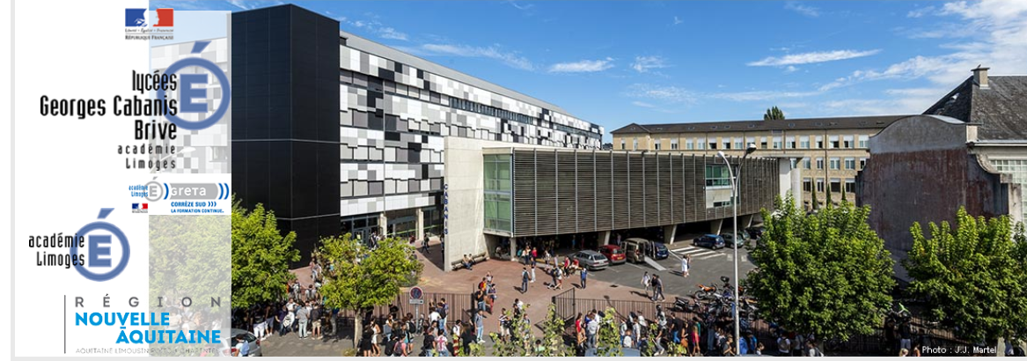

http://www.lyc-cabanis.ac-limoges.fr/

Lycée professionnel Georges Cabanis
6, Bd Henry de Jouvenel
BP 409
19311 Brive-la-Gaillarde

  - Vocational training field
http://eduscol.education.fr/sti/formations/formations-bac-pro/bac-pro-maintenance-des-equipements-industriels-mei

Vocational advanced level graduates majoring in “Industrial Equipment Maintenance” (MEI) are technicians who are able to :
- Maintain industrial equipment both curatively and preventively,
- Contribute to improving and altering the equipment they work on
- Participate to the installation and setting up of new equipment
- Handle operational parts as well as controlling parts.
[See APPENDIX 1 - Professional worksheet]

  - The concept of MAINTENCIA for Destination Entreprise Challenge

http://www.associationlimousinedeschallenges.com/

http://www.associationlimousinedeschallenges.com/14517-pre_bac.php

Our point is to put up a platform devoted to self-employed technicians specializing in Industrial Equipment Maintenance thanks to the association called “limousine des Challenges”.

The virtual innovative business creation competition DESTINATION ENTREPRISE PRE-BAC CHALLENGE aimed at young vocational students aged 15-22 years old is meant for us to become aware of what the labour market is actually like. This project has enabled us to know our job better and to improve our writing and speaking skills. It has also prompted us to figure out what our professional future will be like.

[See APPENDIX 5 - Time tracking]

1.4 Our team of self-entrepreneurs technicians
The MAINTENCIA platform project is made up of six Industrial Equipment Maintenance technicians.

BROUXEL Industrial Equipment Maintenance
BROUXEL Emilien
Born on 02/02/2001 in Brive-la-Gaillarde (F-19100)
11, avenue de Migoule 19100 Brive-la-Gaillarde
06.37.74.17.98 / brouxel.emilien@gmail.com
2019 – Industrial equipment Maintenance Vocational Advanced Level (in progress)
2018 – National Vocational Qualification in Maintenance (in progress)
2016 – National School Certificate
2016 – School road safety certificate 2
2014 – School road safety certificate 1

DOS SANTOS LEITAO Industrial Equipment Maintenance
LEITAO Mickaël
Born on 24/05/2000 in Brive-la-Gaillarde (F-19100)
Les Cancous 19240 Allassac
07.60.07.74.05 / leitao.mickaelbruno@gmail.com
2019 – Industrial equipment Maintenance Vocational Advanced Level (in progress)
2018 – National Vocational Qualification in Maintenance (in progress)
2016 – National School Certificate
2016 – School road safety certificate 2
2014 – School road safety certificate 1

SAUSSET Industrial Equipment Maintenance
SAUSSET Maurin
Born on 13/01/1999 in Brive-la-Gaillarde (F-19100)
6, impasse du Fournil 19130 St Cyr-la-Roche
06.04.53.13.74 / maurinsausset@yahoo.fr
2019 – Industrial equipment Maintenance Vocational Advanced Level (in progress)
2018 – National Vocational Qualification in Maintenance (in progress)
2016 – National School Certificate
2016 – School road safety certificate 2
2014 – School road safety certificate 1
2012 – First Aid certficate

SHARPS Industrial Equipment Maintenance
SHARPS Daniel
Born on 27/08/2000 in Poole (UK -Dorset)
Sauvent 19170 St Hilaire-les-Courbes
07.82.74.08.17 / Daniel19170.ds@gmail.com
2019 – Industrial equipment Maintenance Vocational Advanced Level (in progress)
2018 – National Vocational Qualification in Maintenance (in progress)
2016 – National School Certificate
2016 – School road safety certificate 2
2014 – School road safety certificate 1
2015 – Volunteer fireman 4
2014 – School road safety certificate 1
2014 – Volunteer fireman 3
2013 – Volunteer fireman 2
2012 – Volunteer fireman 1
2012 – First Aid certificate

SILVESTRINI Tatiana
Born on 29/09/2000 in Brive-la-Gaillarde (F-19100)
2016 – National school certificate
2016 – First aid certificate
2013 – School road safety certificate 1
Tatiana committed herself to this project as of September 2016 until February 2017 yet personal issues forced her to leave school. We definitely wanted her name to appear for her work meant a lot to us, that’s why we are thankful of her implication.

SIMONOT Industrial Equipment Maintenance
SIMONOT Melvin
Born on 10/03/2001 in Brive-la-Gaillarde (F-19100)
Lotissement du Colombier 19270 Ste Féréole
06.89.75.65.05 / melvin.simonot19@gmail.com
2019 – Industrial equipment Maintenance Vocational Advanced Level (in progress)
2018 – National Vocational Qualification in Maintenance (in progress)
2016 – National School Certificate
2016 – School road safety certificate 2
2013 – School road safety certificate 1

1.5 MAINTENCIA organization chart

PLATFORM
MAINTENCIA.com Sales Department
Mickaël LEITAO

Emilien BROUXEL
Self-entrepreneur technician
MAINTENCIA

Maintenance
Companies
(Market rsearch)

MAINTENCIA
Subscription offer
Platform management
MAINTENCIA
* referencing
* updating internet pages

Market research
* for self-entrepreneurs
* for the platform

Connecting customers to self-entrepreneurs
technicians

Signature of
MAINTENCIA Charter
Information for the platform
updating

Monthly regular subscription +
Commission on business
on the brought business
Maurin SAUSSET
Self-entrepreneur technician
MAINTENCIA

Daniel SHARPS
Self-entrepreneur technician
MAINTENCIA

*Companies *Private
individuals
(prospecting)

Maintenance and repairing offer
Tatiana SILVESTRINI
Self-entrepreneure technician
MAINTENCIA

Melvin SIMONOT
Self-entrepreneur technician
MAINTENCIA

1.6 What is MAINTENCIA ?
http://www.onisep.fr/Ressources/Univers-Formation/Formations/Lycees/Bac-pro-Maintenance-des-equipements-industriels

Vocational advanced level graduates majoring in“Industrial Equipment Maintenance” (MEI) are in charge of both curatively and preventively maintenance of industrial equipment.They contribute to improving and altering the equipment they work with as well as they participate to the setting up of new equipment. They can handle operational parts as well as controlling parts. They really have to respect health and safety rules, quality standards or environmental protection regulations.

Industrial Equipment Maintenance” (MEI) technicians repair or fix equipment and properties once they have tested and checked the functioning. Their work can vary depending on the company where they work or the type of equipment they maintain. They use computer-aided technologies for detection and troubleshooting. They perform maintenance supervision tasks and /or planned tasks, they also report problems. They have to be in contact with both machines’users and other maintenance co-workers.

Vocational advanced level graduates majoring in “Industrial Equipment Maintenance” (MEI) can be hired by companies belonging to very different and various economic sectors. They work within the maintenance department and as such they can act on their own or with teammates. They can also supervise the whole maintenance department or half of it.
[See APPENDIX 1 - Professional worksheet]

MAINTENCIA should be able to offer maintenance contracts (both curatively and preventively) and operations in the following fields:

•Industrial Equipment maintenance

* Mechanical maintenance (assembling-disassembling- replacement, machining-

manufacturing)

* Electrical maintenance (adjustment - analysis, installation/standard replacement)

* Hydraulic maintenance (assembling- disassembling, installation-replacement,

adjustment-analysis-study)

• Telecommunication Equipment Maintenance Services

• Street Lighting Maintenance

Traffic lights, event lighting, energy management and optimization, monument lighting

• Maintenance and Building Energy Management

Distribution, heat pumps, cold rooms and freezer rooms, cold units, heating, reversible

air-conditioning

•Maintenance of CCTV surveillance systems

CCTV installation, VDI (Voice-Data-Image) pre-wiring, intrusion detection systems, access control systems, intruder alarm systems

1.6 Description du service MAINTENCIA

STEP 2
Defining the company feasibility

2.1 Industrial equipment maintenance companies
(Search on the net)
Companies - Maintenance and repair of industrial equipment
Metallurgy, mechanics and subcontracting. Industrial subcontracting
- 68 companies in Corrèze, including 1 in Allassac and 5 in Brive
- 54 companies in the Lot
- 732 companies in AQUITAINE :
Dordogne (120), Gironde (284), Landes (77), Lot et Garonne (98), Pyrénées-Atlantiques (153)

2.2 Rival companies in Corrèze
http://www.allez.fr/allez/maintenance.html
Avenue André Malraux,19100 Brive-la Gaillarde 05 55 86 06 45

SEDIB (SAS ) rue Gustave Courbet, ZI Beauregard, 19100 Brive-la-Gaillarde
05 55 23 36 10

FCMS Cheize Frederick Industrial transfer - On-site intervention
Le Bourg 19520 Mansac 06 14 84 73 45

HBME Industrial maintenance La Treille 24120 La Feuillade 05 53 50 83 36

Perez Industrial maintenance
Le Bourg 19600 Chartrier Ferrière 06 23 18 16 90

2.3 Platforms of industrial equipment maintenance companies
A few platforms of industrial equipment maintenance companies are found.If you do a search on the Google search engine with “platforms of industrial equipment maintenance companies”, there are only 2 results : EUROPAGES and SILEX.
http://conseil-services-divers- entreprises.europages.fr/entreprises/France/Sous-
traitant/Maintenance%20industrielle.html

Searches with “COUNTRY”, “TYPE OF BUSINESS ”, “NUMBER OF EMPLOYEES”.
A few one –man companies (7 altogether) are listed in the search “FRANCE”,subcontractor, from 1 to 10 persons although the first pack is free of charge.

https://www.silexfrance.com/silex/public/categories/subcategory.jsf;jsessionid=DF4A5CF71F98CDB0BDAC0EB08C8C2E6?subCategoryCode=MAINTENANCE-INDUSTRIELLE

Industrial maintenance Free trial subscription.

STEP 3
Communicating to get known
(Communication plan)

3.1 MAINTENCIA.com Internet platform

https://maintencia.com/ [first go to https//maintencia.jimdo.com]

3.1.1 A dedicated domain including search engine optimization
The platform is open thanks to the jimdo.com server. The professional version is €78 a year all taxes included (JimdoPRO). The JimdoPRO version allows to get a domain name (MAINTENCIA.com), to link external domain names, to have an e-mail account, three e-mail address redirections, 5GB storage space,10GB bandwidth, 5 password-protected areas, the website visits statistics, a personalized-footer, no Jimdo advertisement.

JimdoPRO is optimized for Smartphones and above all allows to efficiently do the search engine optimization for MAINTENCIA.com (SEO). Indeed the MAINTENCIA platform has to be easily found by potential customers.

Its referencing is of the highest importance in terms of advertising and market research using key words such as: “industrial equipment maintenance, industrial repair, mechanical maintenance, electrical maintenance, hydraulic maintenance, telecommunication equipment maintenance services, street lightning maintenance, maintenance and building energy management, maintenance of CCTV surveillance system, distribution, heat pumps, cold rooms and freezing rooms, industrial refrigeration, heating, reversible air conditioning, focusing, diagnosis, study, assembling, disassembling, standard replacement, installation, energy optimization and management, CCTV installation, VDI (Voice-Data-Image) pre-wiring, intrusion detection systems, access control systems, intruder alarm systems.

3.1.2. An advertisement for each company registered on the site
The platform presents the team of MAINTENCIA technicians, their intervention offers, their specializations and allows the customer to contact the self-employed technician in charge of the platform. He writes down the potential customer’s needs. Next he contacts a platform technician, the one who will be available and who will best fit with the customer’s needs. The self-entrepreneur technician interested by the intervention contacts himself / herself the customer in the name of MAINTENCIA.

3.2 A unique MAINTENCIA corporate identity
All the documents are produced according to the same corporate identity in order to give more visibility to the self-entrepreneurs technicians registered on the MAINTENCIA platform. Each self-entrepreneur technician registered on the platform commits to use the logo of the trade mark MAINTENCIA on all his professional documents and to affix it to his company vehicle. The self-employed technician has to pay for the cost of this updating to standards.

3.2.1 Professional documents

Headed paper Business card

[format A4]

Industrial Equipment Maintenance

Industrial Mechanics
Daniel SHARPS

Sauvent 19170 St Hilaire-les-Courbes
07.82.74.08.17 Daniel19170.ds@gmail.com

Sauvent 19170 St Hilaire-les-Courbes
07.82.74.08.17 Daniel19170.ds@gmail.com

The same MAINTENCIA logo is printed on each quote and invoice document but each self-entrepreneur technician can then print his own contact details.

3.2.2 Silkscreen printing on the company vehicle
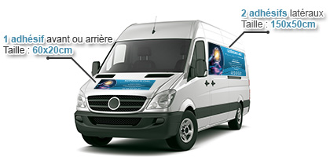
1 front or back sticker Size : 60x20cm
2 side stickers Size : 150x50cm

The sticker is designed directly on the site, 48 hour delivery
Supplier : sticker pro
Address : https://www.stickerpro.fr
Price : 100 € all taxes included (by CC)

STEP 4
Legal status – Setting up one’s self-entreprise

4.1 Position of the self-entrepreneur
www.lautoentrepreneur.fr

MAINTENCIA’s service technicians opt for the status of self-entreprise. Indeed, it is a decent status to start a business, to limit welfare costs and have a simplified management. This activity is carried out as a sole proprietorship and depends on the RSI (Régime social des Indépendants).

The sole proprietorship comes under the tax regime for micro-entreprises and is expected to generate annual revenues that should not exceed 32.900 € for a service activity subjected to ICB (industrial and commercial benefits). No expenses (telephone bills, business trips, etc.) can be deducted by the sole proprietorship. It cannot charge or obtain reimbursement of VAT. Consequently, the following must be mentioned : "VAT not applicable article 293 B of the CGI" on bills and cost estimates.

Every self-entrepreneur person must register online with the RCS (Registre des Sociétés). Registration is free of charge. The person must be qualified (Industrial Maintenance Technician), subscribe to professional liability insurance and open a bank account specifically for business activities.

Upon receipt of the business identification SIRET [Système Informatique pour le Répertoire des Entreprises sur le Territoire, 14 figures composed of 9 figures from the SIREN (The computerised directory of businesses and establishments + 5 figures from the NIC - Numéro Interne de Classement), the self-entrepreneur person will be able to declare and pay taxes and social contributions.

Contributions can be paid every month or quarter online (every 3 months is advantageous to make oneself a cash reserve) and the total is calculated by applying a flat rate based on turnover. A specific reduced rate can be applied if the self-entrepreneur person is eligible for the ACCRE (special aid for unemployed creators and business buyers). The self-employed person can opt for a withholding payment of tax if taxes and contributions are paid simultaneously. He / she will also have to pay the CFE (Corporate Property Tax).

4.2 Modes of search engine optimization on the MAINTENCIA platform
[See Appendix 3 SEO charter on the MAINTENCIA platform]

When the platform is contacted by a maintenance company that wants to be registered, the technician in charge of the platform will provide the required information.
If the potential customer is interested, a SEO charter and an estimate will be sent to him/her. If the technician reaches an agreement with the customer, the latter will join the platform once the other technicians already registered on MAINTENCIA are informed.

STEP 5 - Market study

5.1 Maintenance new requirements

http://www.espace-competences.org/Metier/Fiche/100283

On production facilities
The industrial maintenance technician mainly works on production facilities in factories and on transport facilities (automobile, aeronautics, rail transport, shipyard). The technician together with his / her team is in permanent contact with the company’s internal services and outside partners.
Onsite or remotely
With the birth of industrial computing, working conditions have changed a lot. It is now possible to make repairs without going out of the company: it’s called remote maintenance. The diagnosis is made by phone or via the Internet. In case of emergency, the technician needs to be available and ready to intervene any time. But mind irregular hours, because a breakdown cannot wait.
With software tools
The maintenance technician intervenes on automated equipment and follows a computer programme’s instructions. This expert in computer-assisted maintenance benefits from specialised software tools (diagnosis by interposed expert system, document or spare parts management…).

5.2 Customer canvassing
The MAINTENCIA platform is in itself an excellent way to advertise registered entrepreneurs. It is well referenced by search engines. The company’s webpages are regularly updated according to the indications provided to the platform manager. Thus, every new potential customer can contact the platform manager and be put in touch with a MAINTENCIA technician.
The technician personally solicits potential customers. He / she develops his / her own address book searching business directory, Trade and Companies Registers on search engines.
The technician then sends companies e-mail and makes exploratory visits to offer services.
He / she systematically leaves his / her calling card and offers estimates.
MAINTENCIA ‘s competitive advantages

Being versatile is our asset : we are able to make preventive, curative, enhancing maintenance in hydraulics, pneumatics, in industrial mechanics and electricals.

Each technician will also specialize in what he can do best and clearly indicate it on his / her MAINTENCIA page.

This should not only draw the interest of a maximum of potential customers who will certainly find what they need among the numerous areas of intervention the platform offers but also limit the competition between the companies registered on the MAINTENCIA platform. Favouring the territorialisation of companies’ interventions will also enable to curb competition.

STEP 6
Planning turnover and funding
(Based on two full years, taxes not included)

[See Appendix 4 – Feasibility Scenario]
This business plan is devised for just one microenterprise. But it is a standard plan than can be applied to the concerned maintenance sole traders and can adapt to the management of the MAINTENCIA.com platform.

6.1. Average hourly rate of maintenance intervention
The estimate provides details about the nature of the work to be done. It will also indicate the hourly rate multiplied by the number of hours that have been planned for the maintenance intervention.

Hourly rates of maintenance interventions
Mechanics | Rate 1 | Rate 2 | Rate3 | Rate 4
Assembling - disassembling -replacement  Machining - manufacturing | €36
Electricity
Assembling / standard replacement |  | €42
Adjustment - diagnosis |  |  | €50
Hydraulics
Assembling - disassembling |  | €42
Installation - replacement |  |  | €50
Adjustment - diagnosis- study |  |  |  | €65

VAT included, may be modified without prior notice, non-applicable in the case of renovation or reconstruction (a specific estimate is to be defined).

Average hourly rate : €48

6.2 Professional equipment

6.2.1 Tooling and equipment
Professional equipment : €1,645,87 ATI rounded to €1,650
(Various tooling €1,046,86 ATI, small tooling €349,99 ATI, protection equipment €249,02 ATI)
[See Appendix 2 - Professional equipment]
Computer equipment: €1,350
(printer €150, computer €450, screen €150, tablet €250, telephone €350)

6.2.2 Professional vehicle
vehicle (renting and maintenance) : First rent : €4,585
(maintenance contract included)
Monthly rent : €159 TNI corresponding to €198 ATI for 60 months
Supplier : Citroën Brive http://www.citroen-brive.com/societe/

TNI = Taxes not included
ATI = All taxes included

6.3 Professional expenses
Fuel: €409 / month (for one liter of diesel fuel at about €1.30)
Calculation basis : 7L/100 km for about 200 km/day on average, being 1,000 km/week being 4,500 km/month (54,000 km/year being 270,000 km over 5 years/60 months) being 315 liters of diesel fuel/month

Car insurance : about €600 per year being €50 per month

Phone / Internet : Internet box and communications €53 / month (Free)

Small supplies (paper, cartridges, etc.) : €30 / month

Professional indemnity : about €360 / year being €30 per month

Fixed fee to the platform MAINTENCIA : €960 per year being €80 per month
(+ percentage according to the stuff brought to the technicians registered on the platform MAINTENCIA)

Advertising : €250 (stamp €50, 500 business cards €100 €, screen print of the vehicle €100)

6.4 Costs and taxes

6.4.1 Start up costs
€0 (declaration of the freelancer on the website net-entreprises)

6.4.2 Social costs
RSI – Service provisions BIC - Beneficiaries ACCRE
Y - first three trimesters: 7.50 % / fourth trimester: 13.30 %
Y+1 - first three trimesters: 13.30 % / fourth trimester: 19.10 %
Y+2 - first three trimesters: 19.10 % / fourth trimester and next N: 24.80 %

6.4.3 Amount of the proposed loan
€10,000*
* professional equipment €1,650 + first rent of the vehicle €4,585 + computing and telephony €1,350 being €7,585
* treasury: €2,415 (useful stock for wage supplements at the start and to guarantee the viability of the business / working capital)

Loan interests: 36 months / 3% rate / €291/month instalment / interests N1: total cost €469
MAINTENCIA | DETERMINATION OF THE TURNOVER
 | JAN | FEB | MAR | APR | MAY | JUN | JUL | AUG | SEP | OCT | NOV | DEC
Turnover  (round number) | 1,600 | 2,000 | 2,500 | 2,700 | 3,000 | 3,400 | 3,600 | 2,000 | 2,600 | 2,800 | 3,200 | 3,500
Number of hours of interventions  / Average hourly wage rate: €48 | 34 | 42 | 52 | 56 | 62 | 70 | 75 | 42 | 54 | 58 | 67 | 73

NEEDS |  | RESOURCES
Professional equipment  Hardware and telephony  Professional vehicle 1st rent  Need for working capital | €1,650  €1,350  €4,585  €2,415 | Bank loan | €10,000
Total amount of the needs | €10,000 | Total amount of the resources | €10,000

CALCULATION OF THE NEED FOR WORKING CAPITAL
Customer credits (the customer pays when the intervention is done)  Fuel (for the beginning of the first month)  Phone and Internet (payable in advance)  Small supplies  Car insurance (at the beginning of the first month)  Professional liability insurance (at the beginning of the first month)  Licence fee MAINTENCIA (first month)  Advertising (market research at the start)  Costs and taxes (provision)  Repayment of the loan | €1,111  €400  €53  €30  €50  €30  €80  €250  €120  €291
Need for working capital | €2,415

EXTRACT FROM THE DEPRECIATION SCHEDULE
DUE DATE | DATE | OUTSTANDING CAPITAL | MONTHLY INSTALMENT | CAPITAL SHARE | INTERETS SHARE | INSURANCE | MONTHLY INSTALMENT + INSURANCE
1 | 9/2019 | 9734.19 | 290.81 | 265.81 | 25.00 | 0.00 | 290.81
2 | 10/2019 | 9467.71 | 290.81 | 266.48 | 24.34 | 0.00 | 290.81
3 | 11/2019 | 9200.57 | 290.81 | 267.14 | 23.67 | 0.00 | 290.81
4 | 12/2019 | 8932.76 | 290.81 | 267.81 | 23.00 | 0.00 | 290.81
5 | 1/2020 | 8664.28 | 290.81 | 268.48 | 22.33 | 0.00 | 290.81
6 | 2/2020 | 8395.13 | 290.81 | 269.15 | 21.66 | 0.00 | 290.81
7 | 3/2020 | 8125.30 | 290.81 | 269.82 | 20.99 | 0.00 | 290.81
8 | 4/2020 | 7854.80 | 290.81 | 270.50 | 20.31 | 0.00 | 290.81
9 | 5/2020 | 7583.63 | 290.81 | 271.18 | 19.64 | 0.00 | 290.81
10 | 6/2020 | 7311.77 | 290.81 | 271.85 | 18.96 | 0.00 | 290.81
11 | 7/2020 | 7039.24 | 290.81 | 272.53 | 18.28 | 0.00 | 290.81
12 | 8/2020 | 6766.03 | 290.81 | 273.21 | 17.60 | 0.00 | 290.81
24 | 8/2021 | 3433.69 | 290.81 | 281.52 | 9.29 | 0.00 | 290.81
36 | 8/2022 | -0.00 | 290.81 | 290.09 | 0.73 | 0.00 | 290.81

TOTAL AMOUNT OF THE MONTHLY INSTALMENTS WITHOUT THE INSURANCE: 10469.24 EUROS
TOTAL AMOUNT OF THE INTERETS: 469.24 EUROS
TOTAL AMOUNT OF THE INSURANCE: 0 EUROS

http://www.tableau-amortissement.org/affichage_du_tableau_damortissement_du_credit_ou_du_pret.php

6.5 Forecast profit and loss accounts at Y & Y+1 Registered technicians MAINTENCIA

Year 1 - from 2020 January 1st to 2020 December 31st
Projected turnover from the 01/01/2020 to the 31/12/2020: 32,900.00 € [maximum turnover for a micro-company]
MAINTENCIA | YEAR 1 (2020)
 | JAN | FEB | MAR | APR | MAY | JUNE | JUL | AUG | SEP | OCT | NOV | DEC
Turnover* | 1,600 | 2,000 | 2,500 | 2,700 | 3,000 | 3,400 | 3,600 | 2,000 | 2,600 | 2,800 | 3,200 | 3,500
Number of hours of interventions* | 34* | 42 | 52 | 56 | 62 | 70 | 75 | 42 | 54 | 58 | 67 | 73
advertising |  |  |  | 100 |  |  | 100 |  |  | 100
MAINTENCIA | 80 | 80 | 80 | 80 | 80 | 80 | 80 | 80 | 80 | 80 | 80 | 80
phone line | 16 | 16 | 16 | 16 | 16 | 16 | 16 | 16 | 16 | 16 | 16 | 16
Internet connexion | 37 | 37 | 37 | 37 | 37 | 37 | 37 | 37 | 37 | 37 | 37 | 37
small supplies | 30 | 30 | 30 | 30 | 30 | 30 | 30 | 30 | 30 | 30 | 30 | 30
lease for the vehicle | 198 | 198 | 198 | 198 | 198 | 198 | 198 | 198 | 198 | 198 | 198 | 198
fuel | 409 | 409 | 409 | 409 | 409 | 409 | 409 | 409 | 409 | 409 | 409 | 409
vehicule insurance | 50 | 50 | 50 | 50 | 50 | 50 | 50 | 50 | 50 | 50 | 50 | 50
professional insurance | 30 | 30 | 30 | 30 | 30 | 30 | 30 | 30 | 30 | 30 | 30 | 30
costs and taxes | 120 | 150 | 188 | 203** | 225 | 255 | 270° | 150 | 195 | 372°° | 426 | 465
Interests on borrowings | 291 | 291 | 291 | 291 | 291 | 291 | 291 | 291 | 291 | 291 | 291 | 291
Total amount of the costs | 1,261 | 1,291 | 1,329 | 1,444 | 1,366 | 1,396 | 1,511 | 1,291 | 1,336 | 1,613 | 1,567 | 1,606
Monthly income | 339 | 709 | 1,171 | 1,256 | 1,634 | 2,004 | 2,089 | 709 | 1,264 | 1,187 | 1,633 | 1,894
* Turnover: Average hourly wage rate: €48
** €120 (01/2020) + €150 (02/2020) + €188 (03/2020) = turnover 1st trimester x 7.5% = €458 due by the 30/04/20
° €203 (04/2020) + €225 (05/2020) + €255 (06/2020) = turnover 2nd trimester x 7.5 % = €683 due by the 31/07/20
°° €270 (07/2020) + €150 (08/2020) + €195 (09/2020) = turnover 3rd trimester x 7.5 % = €615 due by the 31/10/20
€372 (10/2020) + €426 (11/2020) + €465 (12/2020) = turnover 4th trimester x 13.30 % = €1,263 due by the 31/01/21
The costs of the last trimester 2020 are due by the 31/01/2021
IMPORTANT : The costs have to be funded every month and be paid every trimester.
Projected annual income N: 15,772 being 1,314 € per month on average

Year 2 – from 2021 January 1st to 2021 December 31st
Projected turnover from the 01/01/2021 to the 31/12/2021: €32,900.00 [maximum turnover for a micro-company]
MAINTENCIA | YEAR 2 (2021)
 | JAN | FEB | MAR | APR | MAY | JUNE | JUL | AUG | SEP | OCT | NOV | DEC
Turnover | 1,600 | 2,000 | 2,500 | 2,700 | 3,000 | 3,400 | 3,600 | 2,000 | 2,600 | 2,800 | 3,200 | 3,500
Number of hours of interventions* | 34* | 42 | 52 | 56 | 62 | 70 | 75 | 42 | 54 | 58 | 67 | 73
advertising | 100 |  |  | 100 |  |  | 100 |  |  | 100
MAINTENCIA | 80 | 80 | 80 | 80 | 80 | 80 | 80 | 80 | 80 | 80 | 80 | 80
phone line | 16 | 16 | 16 | 16 | 16 | 16 | 16 | 16 | 16 | 16 | 16 | 16
Internet connexion | 37 | 37 | 37 | 37 | 37 | 37 | 37 | 37 | 37 | 37 | 37 | 37
small supplies | 30 | 30 | 30 | 30 | 30 | 30 | 30 | 30 | 30 | 30 | 30 | 30
lease for the vehicle | 198 | 198 | 198 | 198 | 198 | 198 | 198 | 198 | 198 | 198 | 198 | 198
fuel | 409 | 409 | 409 | 409 | 409 | 409 | 409 | 409 | 409 | 409 | 409 | 409
vehicule insurance | 50 | 50 | 50 | 50 | 50 | 50 | 50 | 50 | 50 | 50 | 50 | 50
professional insurance | 30 | 30 | 30 | 30 | 30 | 30 | 30 | 30 | 30 | 30 | 30 | 30
costs and taxes | 213* | 266 | 332 | 359 | 399 | 452 | 479 | 266 | 346 | 535 | 611 | 668
Interests on borrowings | 291 | 291 | 291 | 291 | 291 | 291 | 291 | 291 | 291 | 291 | 291 | 291
Total amount of the costs | 1,454° | 1,407 | 1,473 | 1,600 | 1,540 | 1,593 | 1,720 | 1,407 | 1,487 | 1,776 | 1,752 | 1,809
Monthly income | 146 | 593 | 1,027 | 1,100 | 1,460 | 1,807 | 1,880 | 593 | 1,113 | 1,024 | 1,448 | 1,691
* Turnover: Average hourly wage rate: €48
° N+1 – first three trimesters: 13.30 % / fourth trimester: 19.10 %
Costs of the first trimester: €811 due by the 30/04/21; second trimester: €1,210 due by the 31/07/21, third trimester: €1,091 due by the 31/10/21, fourth trimester: €1,814 due by the 31/01/22
Projected annual income N + 1: 13,882 being €1,157 per month on average (choosing becoming an entreprise)

6.5.1 Matching elements of the profit and loss account concerning MAINTENCIA platform.
Suscription to the platform for the registered contractors
Management of the platform
Registration at the platform  Management of the contractor’s webpage  Commercial prospecting | €80/month per company
+ percentage per deals
Turnover including VAT charged between €100 and €300 | 5% | Between €5 and €15
Turnover including VAT charged between €301 and €600 | 8% | Between €25 and €48
Turnover including VAT charged between €601 and more | 10% | Between €60 and more

The administrator must provide for €78 (including VAT) per year so as to host the platform on Jimdopro website. It allows him to get the domain name MAINTENCIA.com. He doesn’t pay the MAINTENCIA fee as he is the administrator of the platform on his own.

At the beginning, the administrator of the platform MAINTENCIA.com will have to share his time between some activities linked to the maintenance of industrial equipment and managing and developing the platform. Indeed, the platform won’t be profitable enough at the beginning to provide him with minimum sales revenues. Consequently, he will have to own the same equipment than his other self-entrepreneur colleagues in industrial maintenance.

The self-entrepreneur administrator of MAINTENCIA.com platform will take care of his time management, maintenance interventions, business development and the management of the platform.

Three steps are necessary for the administrator to make new clients :
1. Prospect new clients in the industrial maintenance field for his own company,
2. Redirect these clients quoted above via the platform for the registered companies,
3. Prospect new contractors specialized in industrial maintenance so that they can join the platform.

A prospected entreprise can be interested in industrial maintenance as well as registering on the MAINTENCIA.com platform.

6.5.2 Some comments about the possible evolutions of MAINTENCIA project.

The gradual workload rise of MAINTENCIA.com platform should increase the time spent to run and develop the platform and it should decrease the time spent to industrial maintenance interventions. In the end, the administrator might focus totally on managing and developing the platform. If such thing happened after two working years, he could cancel the rental agreement of his occupational vehicle and then, not renew it. Moreover, he could resell his equipping of industrial maintenance.

We notice that at the end of the second working year (from January 1st 2021 to December 31st 2021), the revenue projections have decreased. Indeed, the micro-enterprise has broken away from the French scheme ACCRE and consequently, the payroll tax increases.

At this stage, each self-employed contractor will have to think about turning his micro-enterprise into a traditional business so that he can increase his turnover as well as his income.

APPENDIX 1 - Becoming an industrial maintenance technician

http://www.onisep.fr/Ressources/Univers-Metier/Metiers/technicien-technicienne-de-maintenance-industrielle

Required skills

Taste and interest in technical and vocational knowledge
Companies seek for professionals who are familiar with automatic, mechanic, hydraulic, pneumatic, electrical, electronic and electro-technical systems. If you are highly interested in the latest technologies, and ready to keep constantly your skills up, this job is for you.

A communications expert
If you are a champion in the technical field, that is great but it is not enough. You must be able to inform, to listen, to communicate too. Firms open their doors to the ones who like teamwork so as to solve complex problems.

Adaptability
Nowadays, firms seek for professionals who are flexible, available and ready to challenge themselves in order to evolve better. They will really roll out the red carpet if you are a multi-skilled person, able to adjust constantly either to new equipment or to new breakdowns. If you like routine, please do not apply !

The different jobs
technicien / technicienne de maintenance industrielle
Cars, robots, tractors, planes … industrial maintenance technicians work on many different vehicles. Their motto : prevention is better than cure. They do their best to avoid breakdowns.

Nature of the work

Anticipating a breakdown
Avoiding a fatal breakdown and a stopping of the production is the very first objective of the industrial maintenance technician. The smallest technical failure can generate expensive extra costs. So, it is best to count on control and routine maintenance of the machines.

Repairing
If a breakdown happens despite all this, you must face it rapidly. First, thanks to tests and measures, the technician diagnoses and takes all necessary steps. Then, if needed, he must swap out defective parts, modify the settings of the machines, or correct the data of a computer program which controls the automated machines. To finish, he puts the machines back into service once they are repaired.

Optimizing the production tool
Trying to – make the tool production more reliable, - improve it, - explore ways to reduce costs : these are the missions of an industrial maintenance technician. As he is always on the lookout for the latest technological evolution, his job is to find and to suggest solutions so as to optimize the safety and the performance of the different equipment and machines used in the production line.

APPENDIX 2 - Professional equipping

1. Various tools
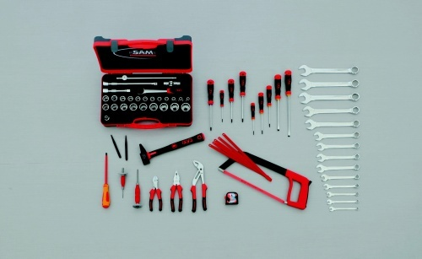
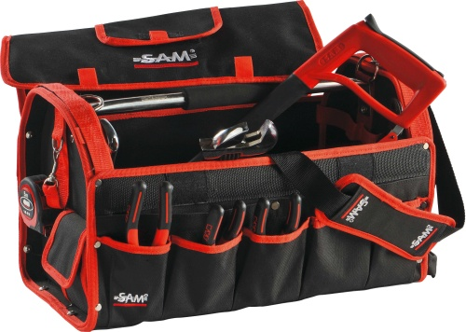

Textile toolbox
Textile toolbox – Overall dimensions 550X270X300mm
Delivered without tools but with two plastic boxes to store small parts. A strap to store a level.
Inside and outside the toolbox, different pockets to store tools. Textile 600 denier.
Weigh : 3.4 kg
https://www.orexad.com/la-selection-de-111-outils-avec-caisse-a-outils-textile-pour-le-technicien-de-maintenance-industrielle/p-0149-5201390

201-25B Slip-joint push-button multigrip polished chrome-plated pliers
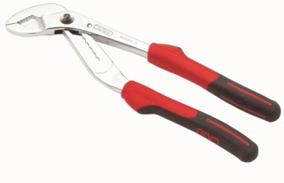
Norms: NF ISO 8976 - DIN ISO 8976
Easy and quick one hand adjustment,9 positions, anti-finger pinch system, full size: 60mm, Thin jaws, The inter-slotted branches bring more safety, bi-material handle, supple axle ( After-sales service).
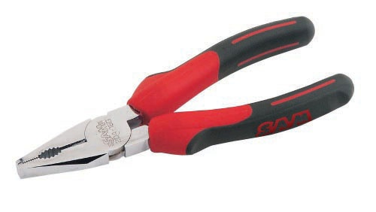
Polished chrome-plated pliers
Norms : NF ISO 5746 / Bi-material branches, Forged in steel with chrome-vanadium, high gripping power, Nose grooved for a better tightening, Function cut thread integrated for hard steel thread.

Chrome-plated polished diagonal cutting pliers
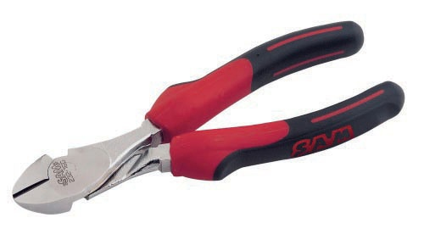
Norms : NF ISO 5749 / Bi-material branches, Forged in steel with chrome-vanadium, Performance increased thanks to the high tempered frequency process, For thread hard piano wire up till 2,5 mm succeeding pattern.
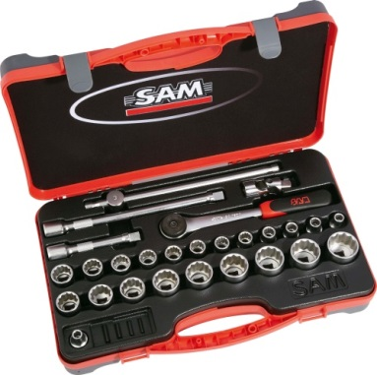
75-SA27 Toolbox 1/2" of 27 tools in mm
Norms : NF ISO 1711-1 - NF ISO 2725-1 - NF ISO / 3315 - NF ISO 3316
Bi-material box 652-BM1 : 425 x 280 x 92 mm. Platine 652-P6.
Soft polished chromed finishing. Weight : 4,1 kg.

Rivter hammers SAMSOPLUS
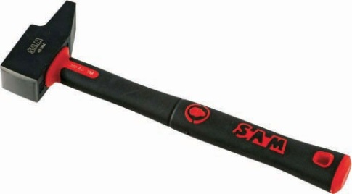
Norms: NF E71-016 - ISO 15601 / Fiberglass armed ergonomic handle, fined polished conic head, antisliping matérial, forged head in carbon steel, epoxy glue handeling.
http://www.bati-avenue.com/sam-outillage-marteau-rivoir-samsoplus-9594.html
Mallet with 4 commutable heads
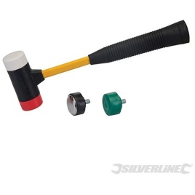
Head of 37 mm of diameter
https://www.manomano.fr/maillet/maillet-4-tetes-interchangeables-300-mm-128677

Nail set
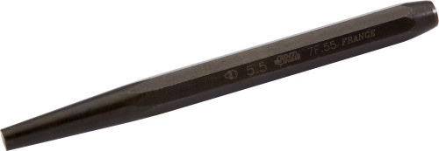
For unstick the pins before using the nail set, octogonal and monoblock body, high resistance spindle, phosphated finishing : no shards risk.

Sam outillage 7-10g Air-Grip Pin Punch Set 9 mm
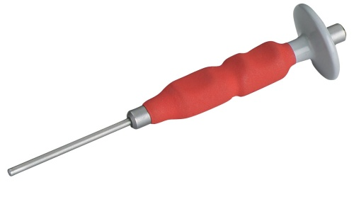

Ergonomic handle for a better grip, Air cushion absorber system, round body, high-resistance bolts, Glass bead finished surfaces .

https://www.amazon.fr/Sam-Outillage-7-10G-Air-Grip-Chasse-goupilles/dp/B008EM4JEE

Electrician's S1 round blade slotted head screwdriver
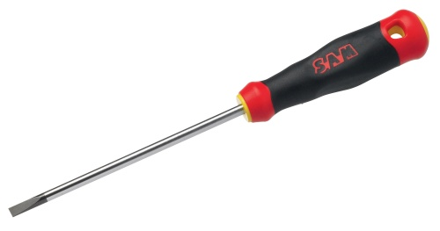
Normes: NF ISO 2380-1 - NF ISO 2380-2 - DIN 5264 / Chrome-plated blade with burnished tip. The end of the blade is milled for easy access to the screw, especially in connecting blocks. Ergonomic bi-material handle. Immediate identification of the slotted tip thanks to the yellow colour on the handle.
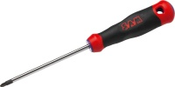
Pozidriv® S1 round blade screwdriver
Normes: NF ISO 8764-2 - NF ISO 8764-1 - DIN 5264
Chrome-plated blade with burnished tip. Ergonomic bi-material handle. Immediate identification of the Pozidriv® tip thanks to the purple colour on the handle
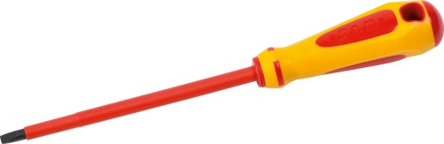
Electrician's SAMSOFORCE® round blade slotted head screwdriver
Normes: NF ISO 2380-1 - NF ISO 2380-2 - DIN 5264
For difficult access.

791 Lever type SAMSOCUT® metal saw
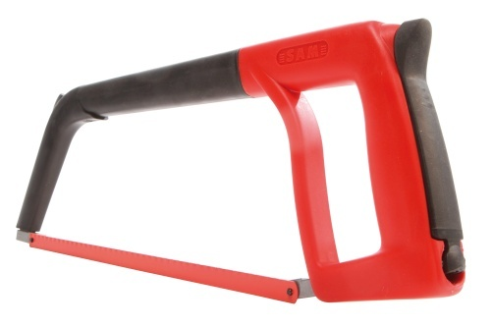
Normes : NF E73-073 Bimaterial handle and guide stop.
Hacksaw - Samsocut - Adjustment Tension - By Lever And Handle - Coating Elastomer
http://www.bricozor.com/monture-scie-metaux-791-sam.html?gclid=Cj0KEQiAtqHEBRCNrdC6rYq9_oYBEiQAejvRlx0dJqL_OkTsD8qUAWBYJEHaW91haRDerU54Sh91RlkaAlyd8P8HAQ
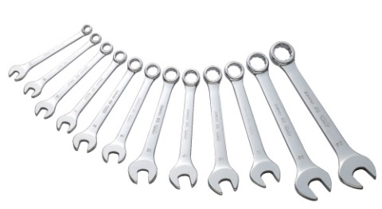
Silverline Tools - Combination Spanner Set 14pce - 8 - 24mm
Reference: ME68286
Open and bi-hexagonal ends with 15° offset for greater access. Hardened and tempered, drop-forged chrome vanadium. High quality fully polished finish. Ultra-strong ballistic nylon storage roll. Includes sizes 8, 9, 10, 11, 12, 13, 14, 15, 16, 17, 19, 21, 22 and 24mm.

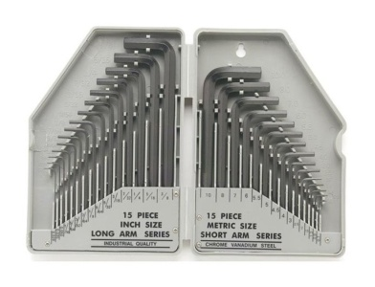
Megastore 247 - Allen Wrench Set - Imperial Hex Tool Kit - All Sizes - 30 Pieces
Reference: ME2231880 - 30pc Hex Key Set
Contains every size you will ever need! Forged from alloy carbon steel, heat treated Supplied in a secure storage case.

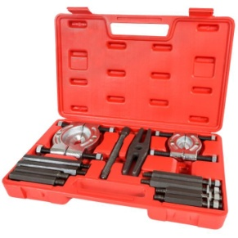

Tectake 12 Pcs Bearing Splitter Gear Puller Fly Wheel Separator Set

With Box Tool Kit

MEDIAFLEX® ABS casing short tape measures
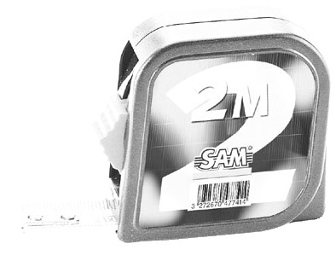
ABS casing.
Band measure.
Ultra compact and light casing.
Band automatic return.

Small tools cost : €1,046,86 € ATI

2. Electrical tools
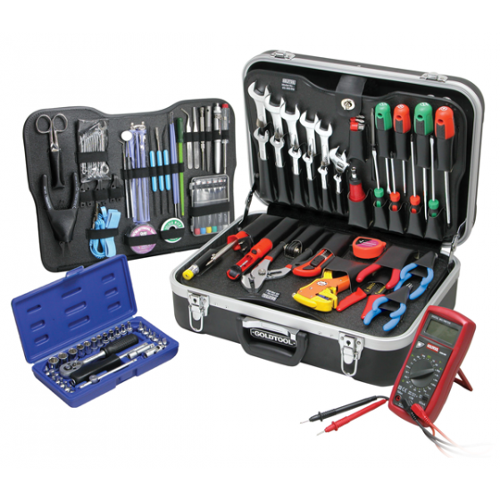

Welding: 1 30 watt soldering iron, 1 soldering iron stand base,
1 solder reel, 3 welding tool, 1 desoldering pump, 1 disoldering wick,
1 antistatic wrist strap

Test devices: 1 digital multimeter, 1 current tester,
1 inspection kit

Wrenches and Pliers: 21 combination wrenches, 7 hex wrenches,
1 6'' adjustable spanner, 1 circlip pliers, 1 crimping tool, 1 10"" water pump pliers, 1needle-nose pliers , 1 pair of cutting pliers, 1Strong tip tweezer set

Ratchets and sockets: 1 reversible ratchet wrench, 1bit holder with ratchet, 3 extension cords,
24 sockets, 15 screwing ends

Screwdrivers: 6 precision screwdrivers, 8 standard screwdrivers, 1 alignment screwdriver set

Miscellaneous: 5 precision files, precision scissors, 1 electrician knife, 1automatic wire stripper,
1 precision cutter et 13 blades, 1hook connector, 1Tape measure

Electrical tools cost: €349,99 ATI
http://www.selectronic.fr/valise-d-outils-d-electronique-135-pieces.html

3. Protective equipment

Safety gloves - 1000 V
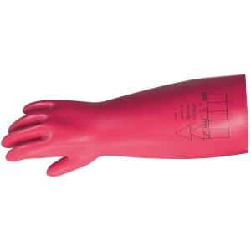
€66.37 ATI
http://www.cazabox.com/gant/5834-gant-jetable-en-latex-vendu-par-100-mp-hygiene-4012078587679.html?gclid=Cj0KEQiAtqHEBRCNrdC6rYq9_oYBEiQAejvRl-ZWlALSGDJM2YnpotvENB5n-YHjhgf6nGYM34w5bcgaArl78P8HAQ#/taille-9?LGWCODE=583410090;129377;7555

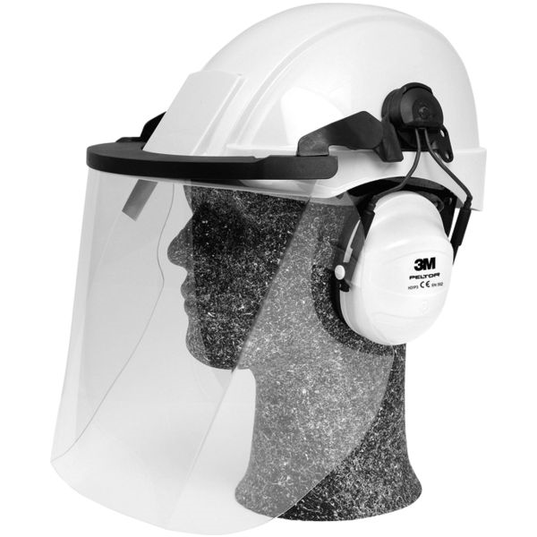
Electrician’s helmet
€62.65 ATI
https://www.quincaillerie.pro/produit/p177989/casque_electricien_3m_g21019?flxrid=ccdc2d1f-2218-4663-ae99-438f1f700311&utm_source=gshopping&utm_medium=cpc&utm_campaign=fluxcenter

Safety boots and protective gown
€120 €

Protective equipment cost: 249,02 € TTC

Tools total cost: €1,645,87 ATI
1. various tools cost : €1,046,86 ATI
2. small tools cost: €349,99 ATI
3. protective equipment : €249,02 ATI

APPENDIX 3 SEO charter on the MAINTENCIA platform (summary)

MAINTENCIA is an Internet platform enabling to advertise for any industrial maintenance self-entrepreneur who subscribes to it so as to give him/her more visibility. This platform shows off a team of entrepreneurs-technicians, the interventions they offer and enables them to be put in touch with potential customers. Each entrepreneur-technician has his/her own page on the online platform and commits to provide all the information needed for its updating.

As for him/her, the administrator of MAINTENCIA platform commits to prospect any customers seeking for maintenance and repairing interventions and to put them in touch with one of the platform’s technicians according to the following criteria : availability, distance, specialised skills. Several technicians may take part in the same work site. In this case, they will have to divide both the tasks and invoicing. The administrator of the platform MAINTENCIA may be in charge of paying the transaction with the customer for all the technicians.

1. Signing up on MAINTENCIA platform
The entrepreneur-technician who wants to subscribe to MAINTENCIA platform will have to pay for a licence-fee of €80 per month to the self-entrepreneur administrator of the platform. Besides, he/she will have to pay a commission on the turnover (including all taxes) he will have done with a customer found thanks to MAINTENCIA platform.

Administrating the platform
Signing up on the site  Market research | €80 / month / business
+ commission / transaction
Turnover including all taxes between €100 and €300 | 5% | between €5 and €15
Turnover including all taxes between €301 and €600 | 8% | between €25 and €48
Turnover including all taxes €601 and over | 10% | €60 and over

2. An advertisement for each maintenance business registered on the site
The platform shows off the team of MAINTENCIA technicians, the interventions they offer to do, their specialisations and allows customers to contact the self-entrepreneur technician in charge of the platform. The latter takes note of the needs of the potential customer. Then, he selects and contacts one technician of the platform, the one who will be available and will best correspond to the profile required by the customer. The entrepreneur-technician interested in the intervention will directly contact the customer on behalf of MAINTENCIA.

3. A unique corporate identity card
All the documents are made according to the same corporate identity card and rules so as to give more visibility to the entrepreneurs-technicians who signed up on the MAINTENCIA platform. Thus, all the documents (estimates, bills, business cards…) of the platform’s technicians will have to be stamped with the logo of the brand MAINTENCIA. Each technician will then have to adapt his/her documents according to his/her business’ contact details. The self-entrepreneur technician will also have to put the logo of the brand on his/her vehicle(s). He/she will pay for the costs due to this MAINTENCIA upgrading process.
The entrepreneur-technician who is registered on MAINTENCIA platform strictly commits to respect this legal quality charter ; if he/she doesn’t, he/she may be unsubscribed.

MAINTENCIA is an advertising brand which is shared without any legal capacity. As a consequence, only the entrepreneur-technician’s responsibility can be involved if need be, as a business providing the services of industrial facilities’ maintenance, as part of its service deliveries to its customer businesses. Each technician is himself/herself an entrepreneur and has his/her own legal capacity.
Each technician who signed up on MAINTENCIA platform draws up his/her own estimates, invoices his/her own service deliveries to his/her customer businesses and commits to take up a professional insurance.

APPENDIX 4 - Feasibility study

2016/2017
First year course in Industrial Equipment Maintenance - 2MEI
First steps towards setting up the project through the DESTINATION ENTREPRISE CHALLENGE

2017/2018
Second year course in Industrial Equipment Maintenance
June 2018 : National Vocational Qualification in Maintenance - BEP MEI

2018/2019
Final year Course in Industrial Equipment Maintenance
June 2019: Industrial Equipment Maintenance Vocational Advanced Level

July-December 2019 Setting the project on course
Registering at the national employment agency as a job seeker
Applying for the ACCRE (financial government support to entrepreneurs )
Setting up a self-entrepreneur project
(adapting and updating the DESTINATION ENTREPRISE CHALLENGE project)

Registering as a self-entrepreneur
Opting for a quarterly payment of social security contributions

Applying for a bank loan
Purchasing equipment
Renting a professional vehicle
Soliciting customers

Applying for the ACCRE – Financial government support to job seekers setting up their business
In order to benefit from reduced contribution rates, job seekers setting up a business or taking it over have 45 days at the latest to fill in a form online, sign it and send it after they have completed their business declaration at the Business Formalities Center in their local URSSAF (Association for the Collection of Social Security Contributions). This form must be enclosed with
the notifications and a copy of your declaration of self-employment.

January 2020
01/01/2020 start-up

Annual turnover € 32,900
Estimated monthly turnover € 2,740

First declared period from 2020/01/01 to 2020/03/31

April 2020
First payment of social contributions and taxes (2020/04/30) –first quarter of 2020

ANNEX 5 - Time tracking

27th September 2016 - letter from the Rector of the Academy of Limoges
Subject: 26th CHALLENGE DESTINATION ENTREPRISE- 2017
“(…) The Academy of Limoges has been supporting the Limousin Association of Challenges (A.L.C) every year since its birth. This exercise promotes the synthetic use of knowledge coming from various school subjects, while developing common sense, curiousity, listening, communication, teamwork, and obstinacy. (…)Moreover, a part of it consists in having to write and defend the project in English and ,as far as the winner is concerned, to represent France in a European contest. Innovation, creativity, cultural international openness, craft and industry are particularly emphasized, but projects for service companies, social economy or associative activities are also welcome.”
In Corrèze : Mathieu Blény mathieu.bleny@leschallenges.com

Monday, October 10th 2016: Phone contact with Mathieu Blény of the A.L.C.
- Appointment booking with a volunteer of the A.L.C. to gather information about the CHALLENGE DESTINATION ENTREPRISE

Tuesday, October 11th 2016: Georges Cabanis Vocational High School Staff Room/Office of the deputy head
- Meeting with Mr. Guy Troncal, the A.L.C representative, Mr Philippe Barbey, teacher in charge of coordinating individual school support to the students in their first year of professional training in Industrial Equipment Maintenance (2MEI), Mrs Josette Debelle, deputy head and Mr. Diop, Maths Teacher.
- Presentation of the CHALLENGE DESTINATION ENTREPRISE policy.
- Presentation of the contest aimed: CHALLENGE DESTINATION ENTREPRISE PREBAC (CDE-PB)
- Required approvals and implementation modalities.
- Mr. Guy Troncal gives Mr. Diop the A.L.C. business card

Wednesday, October 12th 2016: Marbot Disctrict Council, in Tulle
- Launching meeting of the PREBAC CHALLENGE in Corrèze.

Thursday, October 13th 2016: Georges Cabanis Workshops / 2MEI
- Meeting with Mr. Stéphane Crespel, headteacher, and Mr. Emmanuel Lefeuvre (Maintenance teacher)
- Mr Crespel and Lefeuvre are given the A.L.C. business card.

Monday, October 17th 2016- room J111 –individual support class - 2MEI Group A
- Presentation of the PREBAC CHALLENGE to the pupils by Mr. Guy Troncal, coordinator in Corrèze, Mrs Francine Lacombe, treasurer of the A.L.C. in Corrèze and Mr. Philippe Barbey, French teacher
- Unanimous approval of the project by the pupils after consultation.

Monday November 7th 2016 – room J111 – Individual Support Class/ 2MEI Group A
- Brainstorming: Self-entrepreneurship in the field of maintenance: what for?
- Ideas of a name for a maintenance auto entrepreneur business
- Study of the official auto entrepreneur website: : http://www.lautoentrepreneur.fr/
- Other reference site : http://www.auto-entrepreneur.fr/

Monday November 14th 2016 (2-3 p.m.) J111Individual Support Class 2MEI group A
Division of tasks
Step 2 : Emilien and Mickae l: Feasability, Research on the internet
Step 3 : Maurin and Melvin: websites and professional vehicles rental
Step 5 : Daniel and Tatiana: -index of potential customers in the South West of France
Each contestant has to look for:
- The price of a full industrial equipment maintenance toolbox

- A name for his/her own business as well as a name for the platform website
The drafts must be typed and saved on a USB flash drive, so that they can be easily shared and edited for the final project.
http://www.barbeypedagogie.fr/7-activites-pedagogiques/agir-créer-une-entreprise/

Thursday, November 17th 2016 Application for DESTINATION ENTREPRISE CHALLENGE
http://www.associationlimousinedeschallenges.com/14517-pre_bac.php
Captain of the team: Daniel Sharps
Support teacher: Mr. Philippe Barbey (French and History teacher)
Group A of the first year students in Industrial Equipments Maintenance (6 pupils)
5 male students (whose one is an English native speaker) and 1 female student
Self entrepreneur Challenge MEI

Monday, November 21st 2016 (2 to 5 p.m.) J111 Individual Support Class Group A
Presentation of the self entrepreneur status http://www.lautoentrepreneur.fr/
- Turnover, social contributions, taxes, tax return, draft budget, business expenses
- Setting up the operational project for September 1st 2018 (year 1, 4 months)
- Research for the cost of a full industrial equipment maintenance toolbox
- Market research (index)

Monday, November 28th 2016 (2-5 p.m.) J111 Individual Support Class Group A
Teamwork Steps 2, 3, 5 :
- Step 2 : Checking the feasibility of the project on the internet
- Step 3 : Looking for professional vehicules rental, screen printing
- Step 4 : Editing the self-entrepreneurs CVs and particulars
- Step 5 : Market research
Appendix 1 : Updating the project schedule
Appendix 2 : Feasibility study

Monday, December 5th 2016
The works are compiled and the writing of the project is in progress (updated December 16th 2016)
The Individual Support classes will resume on Friday afternoons in January 2017 after Christmas holidays.

Christmas break: The contestants will go on with their searches on holiday. The results will be shared and integrated into the draft in progress in January 2017.

Friday, January 6th 2017 (2-3:30 p.m.) school library, 2nd floor
- Maurin and Melvin, presentation of the platform : http://maintencia.jimdo.com/
- Mrs Francine Lacombe, treasurer of the A.L.C. in Corrèze, reviews the work that has been done. She speaks on the accounting section of the project and explains the role of the midterm jury.

Wednesday, January 11th 2017- Brive Chamber of Commerce - Midterm Jury
The team presents their project progress to the jury (Jury 3).
Departure from high school: 1:15 p.m. / Arrival at the Chamber of Commerce 1:30 p.m. / oral Presentation time: 1:45 p.m.
Appropriate dress required

Friday, January 13th 2017 (2 to 3:30 p.m.) school library, 2nd floor
Step 2 - Emilien, Mickael, Tatiana - equipment catalogue, service catalogue and price list (cf. Mr Lefeuvre and maintenance websites – ex: Allez and cie)
- Maintenance operations hourly rate
Step3 : Maurin, Melvin : Virtual Platform (Filling in the companies pages), Professional vehicule rental (calculation of costs)
Step 5 : Daniel : Translation of the presentation of the platform into English

Friday, January 20th 2017 (2-3:30 p.m.) School library, 2nd floor
Oral intervention by Mr. Troncal, A.L.C. Corrèze
Writing of the Maintencia platform participation charter, compilation of the researches and draft, updating.
The project is transmitted to Mr. Crespel and Mr. Lefeuvre ( Maintenance teachers), so that they can amend it if necessary.

(Friday, January 27th 2017 (2-7:30 p.m.) Parent -teacher meeting / Classes are cancelled)

Friday, February 3rd 2017 (2 -15:30 p.m.) School library, 2nd floor
Oral intervention by Mrs Lacombe, A.L.C. Corrèze
- Projected profits and loss accounts for the next two years
- Tatiana’s resignation
The project is forwarded to Mrs Lacombe and Mr Troncal for necessary amendments.

Friday, February 10th 2017 (2 -15:30 p.m.) School library, 2nd floor
Last amendments to the Maintencia platform project (teamwork); a final black and white draft is printed out.

Friday, February 17th 2017 (2 -15:30 p.m.) School library, 2nd floor
Oral intervention by Mrs Lacombe, A.L.C. Corrèze
Final proofreading of the whole project and last amendments.
THE WRITING OF THE MAINTENCIA PROJECT FILE FOR DESTINATION ENTREPRISE CHALLENGE - PREBAC IS ACHIEVED.

Winter Holidays: The contestants have to read the whole project and to start thinking of oral scenarios for the jury in May.

Friday, March 10th 2017 (2 -15:30 p.m.) School library, 2nd floor
Writing of the scenarios for the oral hearing.
Colour drafts are printed out for the team, the members of jury and the various people involved.

Friday, March 17th 2017 (2 -15:30 p.m.) School library, 2nd floor
Training for the oral presentation of the project (1)

Friday, March 24th 2017 (2 -15:30 p.m.) School library, 2nd floor
Training for the oral presentation of the project (2)

Friday, March 31st 2017 (2 -15:30 p.m.) School library, 2nd floor
Training for the oral presentation of the project (3)

Friday, April 7th 2017 (2 -15:30 p.m.) School library, 2nd floor
Training for the oral presentation of the project (4)

Friday, April 14th 2017 (2 -15:30 p.m.) School library, 2nd floor
Training for the oral presentation of the project (5)

Spring Holidays: The contestants must know their roles by heart.

Friday, May 5th 2017 (2 -15:30 p.m.) School library, 2nd floor
Presentation of the project to Cabanis high school
END OF THE ORAL TRAINING FOR DESTINATION ENTREPRISE CHALLENGE JURY
(FRENCH)

Thursday, May 11th 2017 BRIVE CHAMBER OF COMMERCE
Oral presentation of the project for the final of DESTINATION ENTREPRISE CHALLENGE - PREBAC (Second departmental finalist)
- Presentation of the EUROPEAN BUSINESS GAMES to the pupils by Mr. Francis OBRY,
Coordinator in Corrèze
- Unanimous approval for the EBG participation by the pupils after consultation.

Monday, May 15th 2017 (10:30-12 p.m.) J111
European Business Game
Training for the EBG Oral in English language (1)

Friday, May 19th 2017 (2-5 p.m.) J111
European Business Game
- More information about the EUROPEAN BUSINESS GAMES by Mr. Francis OBRY
- Training for the EBG Oral in English language (2)

Monday, 22nd May 2017 (2-4 p.m.) J111
European Business Game
Training for the EBG Oral in English language (3)

Tuesday, May 23rd 2017 (2-4 p.m.) J111
European Business Game
Training for the EBG Oral in English language (4)

Monday, 29th 2017 (2-4 p.m.) J111
European Business Game
Training for the EBG Oral in English language (5)

Tuesday, May 30th 2017 (2-4 p.m.) J111
European Business Game
Training for the EBG Oral in English language (6)
END OF THE ORAL TRAINING FOR EUROPEAN BUSINESS GAME JURY
(ENGLISH)

Thursday, June 1st 2017 ENSIL Limoges (engineering school)
- Regional final (5 departmental finalists) - PROJETS CLE - KEY PROJECTS
EUROPEAN BUSINESS GAME SELECTIONS

Aknowledgements
A particular thanks to the Cabanis High School English teachers: Sandrine BAUCHET, Marilyn BORNES, Laurene BOY, Cynthia CERTE, Anne CHAZARIN, Céline DROAL, Sophie GRANGER, Marie-Christine LAVERGNE, Véronique PACAILLE, Jessica ROUZAIROL, for their crucial help in the very rapid translation in English of this file. It was really miraculous. You are a dream team. So, thank you so much, my dear English teachers colleagues.
Philippe Barbey, French teacher.

Nathalie MANDOUX - Cabanis High School Printing Reprography Service – May, 2017

Georges Cabanis High School
Brive-la-Gaillarde
New-Aquitaine Region
France

2017 Destination Entreprise
Challenge Project

Emilien BROUXEL
Mickaël LEITAO
Maurin SAUSSET
Daniel SHARPS
Tatiana SILVESTRINI
Melvin SIMONOT

Equipment Maintenance Service
Technicians Pupils
(Year 11 class)

